Nepal College of Information Technology
Assessment
Fall 2009
Program: IT/CE Time: 3 hrs
Semester: Fall FM: 100
Subject: Numerical Methods PM: 50
Attempt ALL the questions.

1. a. Find the root of the equation x⁴+x²-80=0, correct to 3 decimal place by using Newton-Raphson's method 7
b) Find where the graph y=x³-2x²+1 intersect the parabola y=2x²+3x+1 by secant method. The answer showed be correct to 3 decimal place. 8
2. a) Using Netwon-Gregory interpolating polynomial of degree 3 to estimate the value of f(1.37) from the following data 7

x | 1.20 | 1.25 | 1.30 | 1.35 | 1.40 | 1.45 | 1.50
f(x) | 0.18 | 0.22 | 0.26 | 0.30 | 0.33 | 0.37 | 0.40

b) Fit a geometric curve y=ax^{b} to the following data 8

x | 2 | 4 | 6 | 8
y | 1.4 | 2.0 | 2.4 | 2.6
3. a) Evaluate 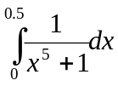 by Trapezoid, rule, Simpson's rule & Simpson's Rule. 7
b) Evaluate 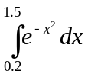by using two and three -term Gausian formula. 8
4. a) Find the dominant eigenvalue and the corresponding eigenvector of the matrix.
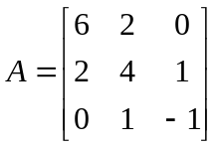 7
b) Solve 8
6x₁-2x₂+x₃=11
x₁+2x₂-5x₃=-1
-2x₁+7x₂+2x₃=5 by an iterative method
5. a) Solve the differential equation 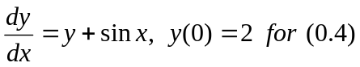by Huen's method taking h=0.2. 7
b) Solve 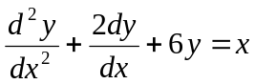 with y(0)=0, y'(0)=1 for y'(0.2) by RK=4th order method. 8
6. a) Solve the following equations by Gauss-elimination method
x+3y+4z=4
x+4y+3z=-2
4x+3y+4z=1 8
b) Find the missing value in the following table for a chemical dissolve in water.

Temperature | 10⁰ | 15⁰ | 20⁰ | 25⁰ | 30⁰
Solubility | 20 | 22 | 23 | ? | 26

7. Write short notes on (Any two) 5*2
a) Convergence of fixed point iteration method.
b) cubic spline
c) Shooting method.

